



ML Ops & Containerization
LAB MANUAL

Disclaimer: The content is curated from online/offline resources and used for educational purpose only
Deploying a Customer Segmentation API with Docker
Objective
Deploy a Customer Segmentation Machine Learning model as a REST API using FastAPI and package the entire application into a Docker container.
Problem Statement
A retail company wants to improve its marketing strategy by grouping customers based on their purchasing behavior. The data science team has developed a Customer Segmentation Machine Learning model using customers' Annual Income and Spending Score. However, the model currently runs only on the developer's local machine, making it difficult to deploy and use consistently across different environments.
As a Machine Learning Engineer, your task is to build a REST API using FastAPI to serve the trained customer segmentation model and containerize the entire application using Docker. The Dockerized application should package the trained model, API, libraries, and dependencies into a portable container that can be deployed consistently across development, testing, and production environments. Finally, verify the deployment by testing the API using Swagger UI and Postman.
Hardware Requirements
- Processor: Intel Core i3 or above
- RAM: Minimum 4 GB (8 GB recommended)
- Storage: At least 5 GB free disk space
Software Requirements
- Windows 10/11, Ubuntu, or macOS
- Python 3.11 or later
- Docker Desktop
- Visual Studio Code
- FastAPI, Uvicorn, Scikit-learn, Pandas, NumPy, Joblib
- Postman (for API testing)
- Web browser (Chrome/Edge/Firefox)

Procedure
Project Structure
CustomerSegmentationDocker/
│
├── app.py
├── train_model.py
├── customer_segmentation.xlsx
├── customer_segment_model.pkl (created after training)
├── requirements.txt
├── Dockerfile
├── .dockerignore
└── README.md

Step 1: Review the Dataset
customer_segmentation.xlsx contains 500 customer records across 3 columns: a CustomerID, and two behavioral features, AnnualIncome and SpendingScore (both stored as decimal values, roughly in the ranges 18-150 and 5-100 respectively). There is no target column - this is an unsupervised clustering problem, so the model groups customers rather than predicting a labeled outcome.
Step 2: Train the Segmentation Model
Create train_model.py:
import pandas as pd
from sklearn.pipeline import Pipeline
from sklearn.preprocessing import StandardScaler
from sklearn.cluster import KMeans
import joblib
# 1. Load the dataset
df = pd.read_excel("customer_segmentation.xlsx")
# 2. Select only the behavioral features used for clustering.
# CustomerID is an identifier, not a feature, and must be excluded, or KMeans would cluster on customer number rather than purchasing behavior.
X = df[["AnnualIncome", "SpendingScore"]]

# 3. Scale the features before clustering
# KMeans groups points by Euclidean distance. AnnualIncome (roughly 18-150) and SpendingScore (roughly 5-100) sit on different numeric ranges; without scaling, whichever column happens to have the larger spread would dominate the distance calculation and skew the clusters.
# Bundling the scaler and the clustering model together in a Pipeline also means app.py automatically applies the exact same scaling at prediction time - it cannot forget to.
model = Pipeline(steps=[
("scaler", StandardScaler()),
("kmeans", KMeans(n_clusters=3, random_state=42, n_init=10)),
])

# 4. Fit the pipeline
model.fit(X)

# 5. Save the trained pipeline (scaler + clustering model)
joblib.dump(model, "customer_segment_model.pkl")
print("Model Saved Successfully")

Run the script:
python train_model.py

Step 3: Create the FastAPI Application (app.py)
Create app.py:
from fastapi import FastAPI
from pydantic import BaseModel
import pandas as pd
import joblib

app = FastAPI(title="Customer Segmentation API")

# Load the trained pipeline (scaler + KMeans) once at startup.
model = joblib.load("customer_segment_model.pkl")

class Customer(BaseModel):
AnnualIncome: float
SpendingScore: float

@app.get("/")
def home():
"""Simple health-check endpoint."""
return {"message": "Customer Segmentation API Running"}

@app.post("/predict")
def predict(customer: Customer):
# Build a single-row DataFrame using the same column names and order seen during training, so the pipeline's scaler transforms the input consistently.
row = pd.DataFrame(
[[customer.AnnualIncome, customer.SpendingScore]],
columns=["AnnualIncome", "SpendingScore"],
)

# model.predict() runs the input through the saved scaler first, then assigns it to the nearest cluster centroid.
segment = model.predict(row)[0]
return {"Customer Segment": int(segment)}

Step 4: Create requirements.txt
Fastapi
uvicorn
pandas
scikit-learn
joblib
numpy
openpyxl

Install the dependencies:
pip install -r requirements.txt

Step 5: Test the API Locally
Start the API:
uvicorn app:app –reload

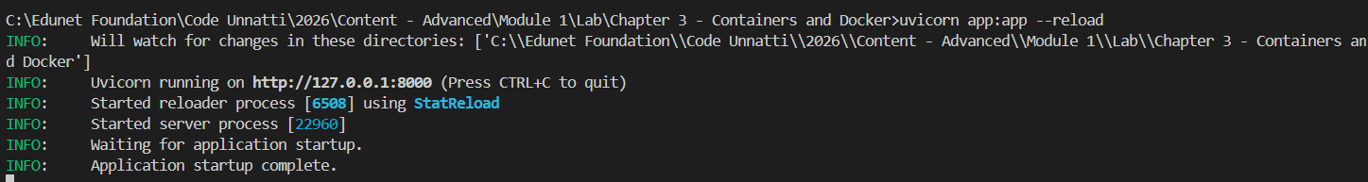
Open Swagger UI:
http://127.0.0.1:8000/docs

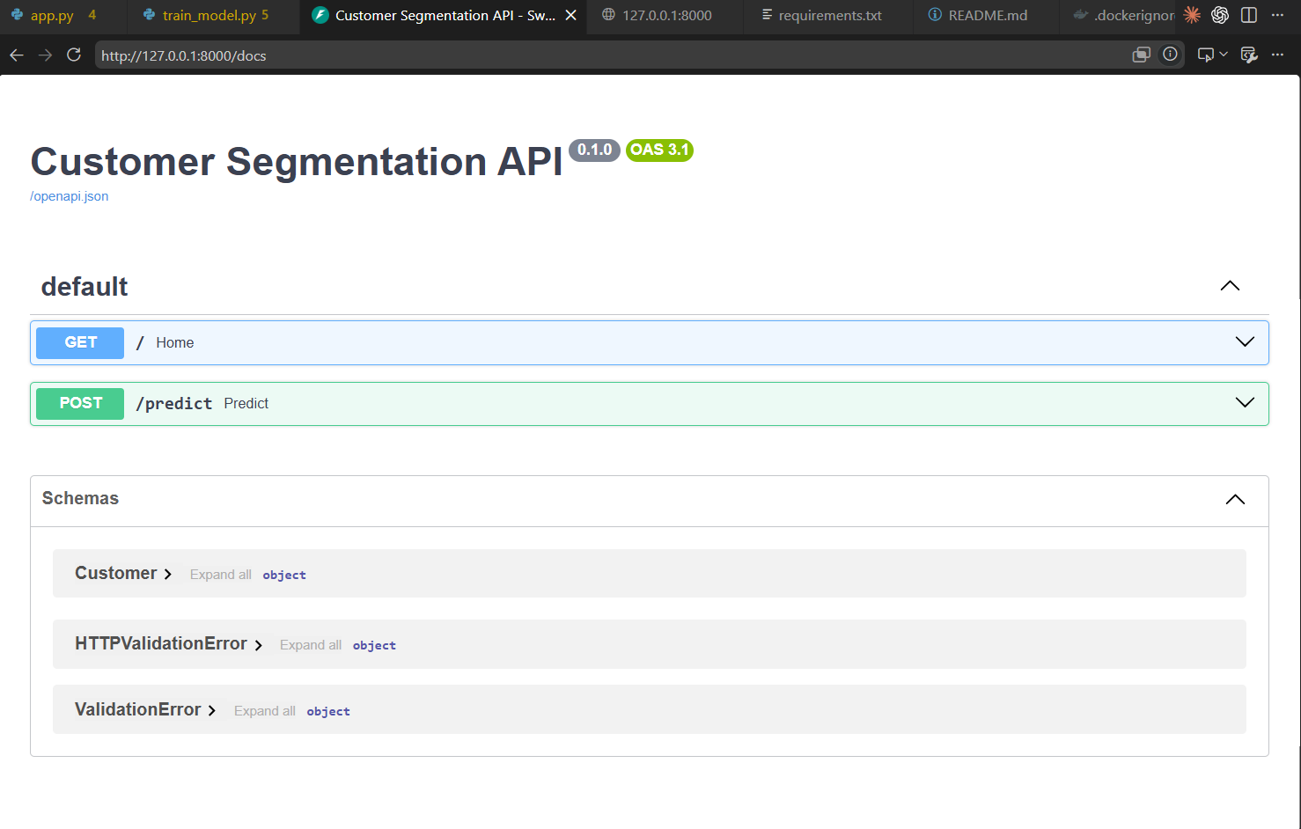

Step 6: Test the Prediction Endpoint
Try a few different customer profiles through POST /predict to see that they land in different segments. A mid-income, mid-spending customer:
{
"AnnualIncome": 80,
"SpendingScore": 75
}

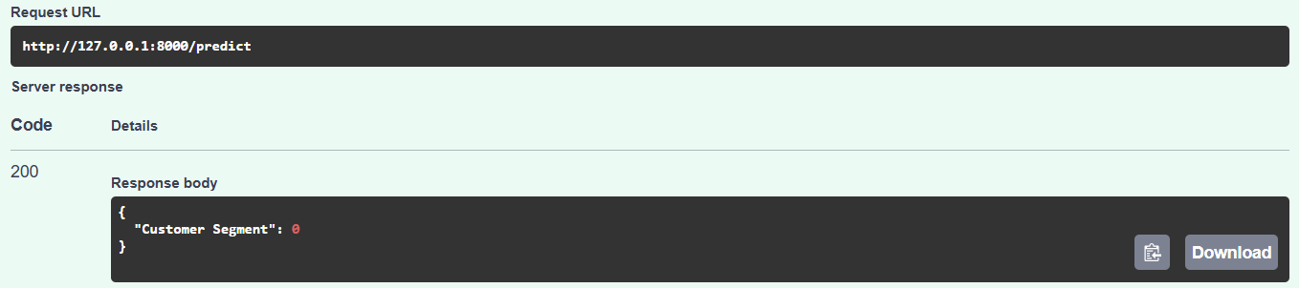
A high-income, high-spending customer:
{
"AnnualIncome": 130,
"SpendingScore": 90
}

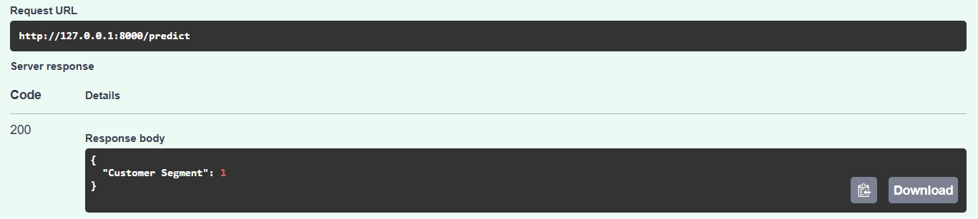

Step 7: Create .dockerignore
Before writing the Dockerfile, add a .dockerignore file so the build context doesn't include unnecessary local files:
__pycache__/
*.pyc
.venv/
venv/
.git/
.gitignore
README.md

Step 8: Create the Dockerfile
Add the lines below in a new created file - Dockerfile
FROM python:3.11-slim
WORKDIR /app
# Copy only the dependency list first, so Docker can cache this layer and skip reinstalling packages on every build unless requirements.txt itself has changed.
COPY requirements.txt .
RUN pip install --no-cache-dir -r requirements.txt
# Now copy the rest of the application code.
COPY . .
EXPOSE 8000
CMD ["uvicorn", "app:app", "--host", "0.0.0.0", "--port", "8000"]

Step 9: Build the Docker Image
docker build -t customer-segmentation-api .

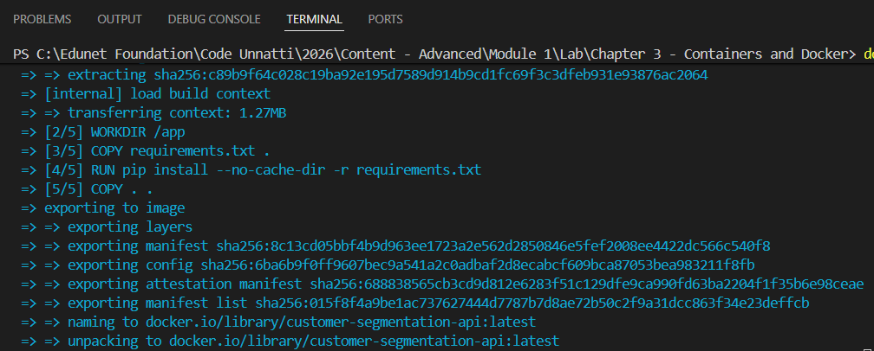
Verify the image was created:
docker images

Step 10: Run the Docker Container
docker run -d -p 8000:8000 --name customer-api customer-segmentation-api

Confirm the container is running:
docker ps

Step 11: Test the Dockerized API
Browser:
http://localhost:8000

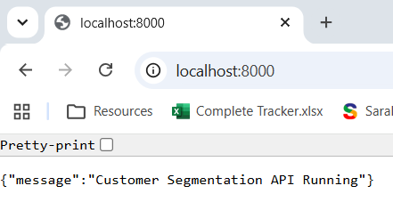
Swagger UI:
http://localhost:8000/docs

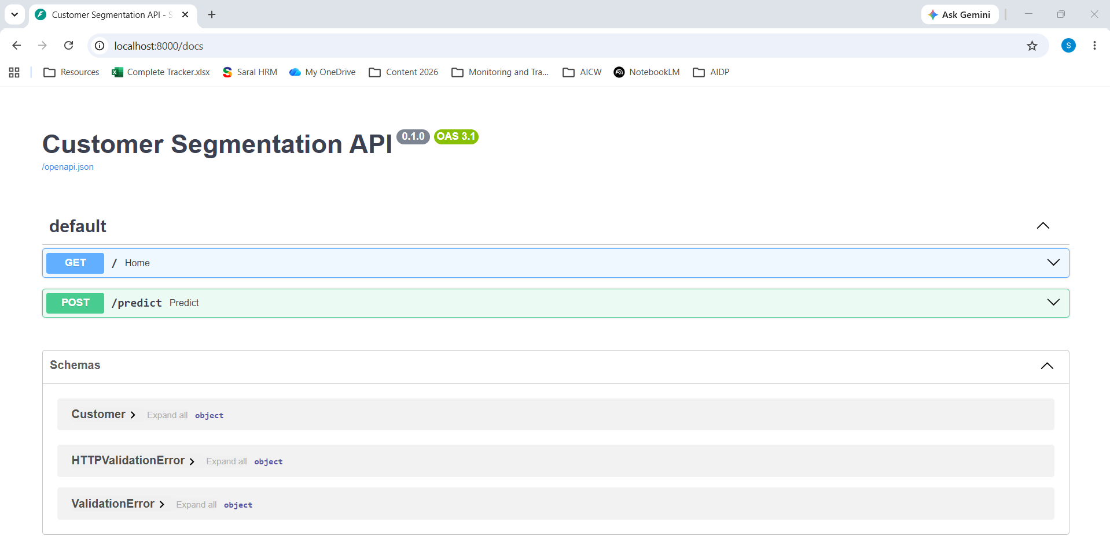

Step 12: Test Using Postman
Body:
{
"AnnualIncome": 70,
"SpendingScore": 85
}

Response:
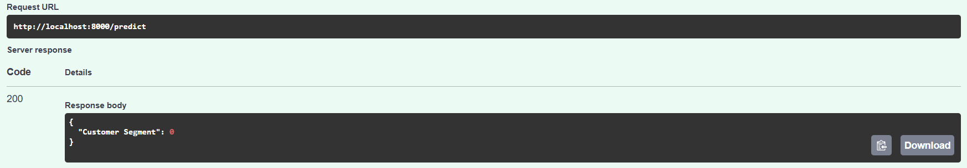
Conclusion
In this lab, a Customer Segmentation REST API was built with FastAPI, backed by a KMeans clustering model, and packaged into a Docker container. The containerized API was verified to respond correctly through the browser, Swagger UI, and Postman, with the same JSON request producing the same customer segment whether the API runs locally or inside the container - confirming that the model, its preprocessing, and all dependencies were packaged together correctly.

